Spatial filtering
Code:
import cv2
import numpy as np
import matplotlib.pyplot as plt
image = cv2.imread('cactus.jpg', cv2.IMREAD_GRAYSCALE)
if image is None:
print("Error: Image not found.")
exit()
gaussian_blurred_image = cv2.GaussianBlur(image, (5, 5), 0)
sobel_x = cv2.Sobel(image, cv2.CV_64F, 1, 0, ksize=3)
sobel_y = cv2.Sobel(image, cv2.CV_64F, 0, 1, ksize=3)
sobel_edges = cv2.magnitude(sobel_x, sobel_y)
sobel_edges = np.uint8(np.absolute(sobel_edges))
sharpening_kernel = np.array([[0, -1, 0],
[-1, 5,-1],
[0, -1, 0]])
sharpened_image = cv2.filter2D(image, -1, sharpening_kernel)
plt.figure(figsize=(10, 10))
plt.subplot(2, 2, 1)
plt.imshow(image, cmap='gray')
plt.title('Original Image')
plt.axis('off')
plt.subplot(2, 2, 2)
plt.imshow(gaussian_blurred_image, cmap='gray')
plt.title('Gaussian Blurred Image')
plt.axis('off')
plt.subplot(2, 2, 3)
plt.imshow(sobel_edges, cmap='gray')
plt.title('Sobel Edge Detection')
plt.axis('off')

plt.subplot(2, 2, 4)
plt.imshow(sharpened_image, cmap='gray')
plt.title('Sharpened Image')
plt.axis('off')
plt.show()
Explanation:
- Image Loading: The image cactus.jpg is loaded in grayscale using cv2.imread().
- Gaussian Blur: A Gaussian blur is applied to the image using cv2.GaussianBlur() with a kernel size of (5, 5).
- Sobel Edge Detection: Sobel filters are applied to detect edges in the x and y directions (sobel_x and sobel_y), and the magnitude of the edges is calculated using cv2.magnitude().
- Image Sharpening: A sharpening kernel is used with cv2.filter2D() to enhance edges and details in the image.
- Matplotlib Plotting: The original image, Gaussian blurred image, Sobel edge detection result, and sharpened image are displayed using matplotlib.pyplot in a 2x2 grid layout.
The output will display the four processed images in a 2x2 grid:
- The original image.
- The Gaussian blurred image.
- The image with Sobel edge detection applied.
- The sharpened image.
Let me know if you need any further clarification or modifications!
Output:
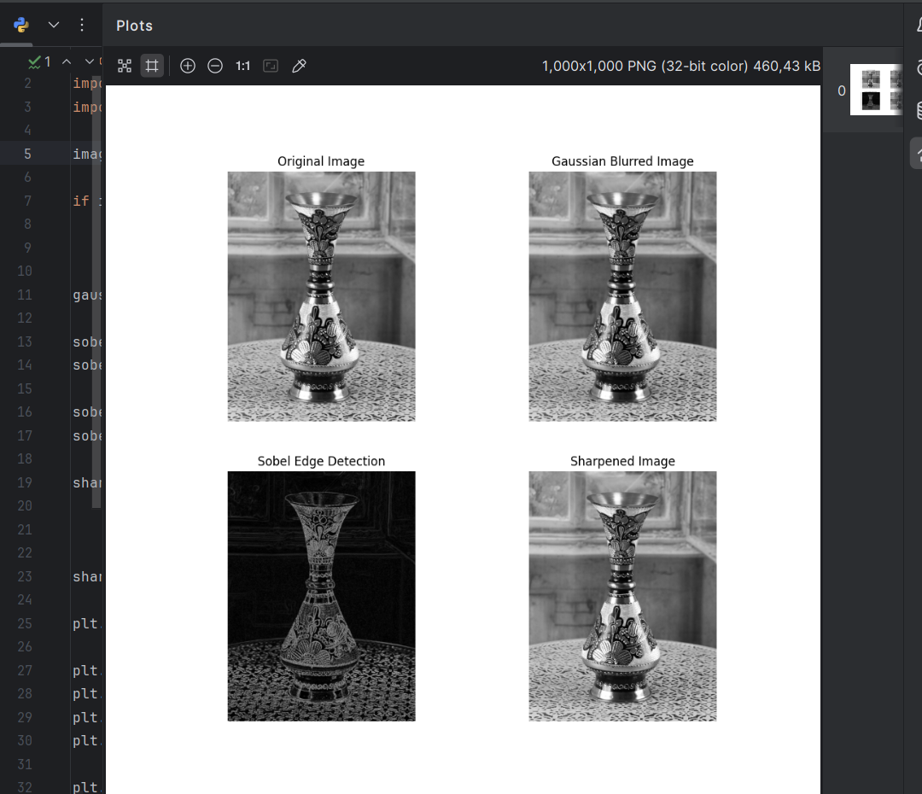
Report:
Objective:
The goal is to apply Gaussian blur, Sobel edge detection, and image sharpening to the grayscale image cactus.jpg and visualize the results.
Methods:
- Image Loading: The image is loaded in grayscale mode using OpenCV’s cv2.imread() function.
- Gaussian Blur: A Gaussian blur with a kernel size of (5, 5) is applied to reduce noise and details in the image.
- Sobel Edge Detection: Sobel operators in the x and y directions are used to detect edges. The edge magnitude is calculated and converted to an 8-bit format.
- Sharpening: A custom sharpening kernel is applied using cv2.filter2D() to enhance edges and details in the image.
- Visualization: The original, blurred, edge-detected, and sharpened images are displayed using Matplotlib.
Results:
- Original Image: The baseline grayscale image.
- Gaussian Blurred Image: A smoother, less detailed version of the image.
- Sobel Edge Detection: A high-contrast edge map highlighting boundaries.
- Sharpened Image: An enhanced version of the image with more defined edges.
Conclusion:
This process effectively demonstrates basic image enhancement techniques. Gaussian blur reduces noise, Sobel edge detection highlights edges, and sharpening enhances image details, making these techniques useful for various computer vision tasks.

